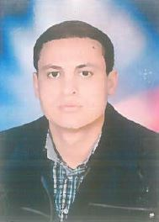
CURRICULUM VITAE
Hussein Ibrahim Ahmed Ibrahim
Full Name  Sex  Date of birth  Nationality  Marital status  Current affiliations | Hussein Ibrahim Ahmed Ibrahim Farah  Male  28/5/1990  Egyptian  Single  Department of General surgery ,Pediatric Surgery Unit, Assiut University Hospital, Assiut, Egypt.  Post-code: 71111, EGYPT.  Phone: Work: +2-088-2414564.  E-mail: husinfarah@aun.edu.eg
Speciality  Subspeciality  Advanced Skills | General Surgery.  Pediatric surgery  Neonatal surgery  Laparocopic surgical interventions

Clinical Experience
Assiut, Egypt (2014-2017):
Assiut University Hospital (AUH), Department of General surgery Department ,140 bed for adult patients for different general surgery disease, Assiut University Emergency Unit for Surgical emergency
Pediatric Unit of Surgery , Assiut University Hospital Of Pediatrics (2017-till now):
It is the first specialized center in Pediatric Surgery in Upper Egypt and now is already in work.

Teaching & Academic Experience
Teaching sessions:
- Teaching Pediatric Surgery (Lectures and Clinical Rounds).
Writing & Editing:
- Patient sheet and data base
- Postgraduate logbook and course specifications

